**SHELL SCRIPT:**

**Task:**

**Adding terraform init and adding a input of terraform workspace and run with terraform plan by using Shell Script**

**Step:1:-**

Creating the script file

In that script file:

# vi two.sh

#!/bin/bash

terraform init

terraform workspace new $1

terraform workspace select $1

terraform plan --out $2

🡺 save the file

**Step:2:-**

Creating terraform file also

# vi instance.tf

module "ec2_instance" {

  source  = "terraform-aws-modules/ec2-instance/aws"

  version = "~> 3.0"

}

🡺 save the file.

After run the script by using below command

**Step:3:-**

# sh two.sh newonet newtf

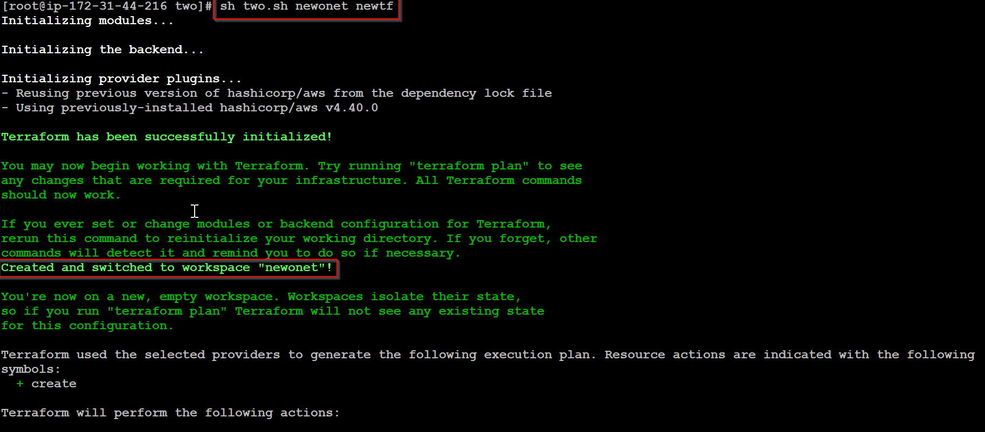

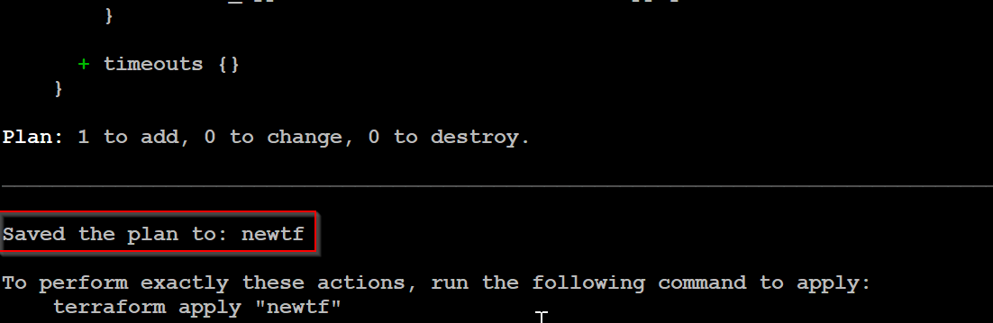



The **new workspace is created** as **newonet** and as well as **terraform plan** is saved to **newtf**.